# PROJECT REPORT CA - 2

CSM216

(PYTHON PROJECT)

COMPUTER SCIENCE AND ENGINEERING

## Submitted by:

Shaik Abdul Khader Jilani

12316430

K23CH

ROLL NUMBER: 66

## Submitted to:

Mr. AMAN KUMAR

LOVELY PROFESSIONAL UNIVERSITY



# ACKNOWLEDGEMENT

I, Shaik Abdul Khader Jilani, a student of Bachelor of Technology under Computer Science and Engineering discipline with Data Science and Machine Learning specialization at Lovely Professional University, Punjab, hereby declare that all the information furnished in this project report is based on my own work and is genuine.

Shaik Abdul Khader Jilani

12316430

**TABLE OF CONTENTS**

1. Introduction
2. Objectives and Scope of the project
3. Application tools
4. Project design
5. Flowchart
6. Summary
   1. **INTRODUCTION**

In today’s interconnected digital world, where data breaches and cyberattacks are becoming increasingly frequent, securing sensitive information is more critical than ever. Weak passwords remain one of the most common vulnerabilities exploited by attackers to gain unauthorized access to personal, corporate, or financial systems. Studies show that many users tend to use predictable, easily guessed passwords, or reuse the same passwords across multiple platforms.

These practices significantly increase the risk of identity theft, data breaches, and other malicious activities.To mitigate such risks, the adoption of strong, unique passwords for each account or system is a vital step in enhancing cybersecurity. However, creating and remembering strong passwords can be challenging for users. This challenge has led to the need for reliable tools, like password generators, that can automatically create secure, random passwords without user effort.

This project aims to address this need by designing a robust password generator capable of producing strong, random passwords tailored to diverse user requirements. The tool will leverage advanced algorithms to ensure high entropy and unpredictability in password generation. It will allow users to customize parameters such as:

* Password length, based on required security levels (e.g., longer passwords for higher security).
* Inclusion or exclusion of specific character sets, such as uppercase letters, lowercase letters, numbers, and special symbols.
* Avoidance of ambiguous characters (e.g., “0” and “O,” or “l” and “1”) for better readability.

In addition to generating passwords, this tool can integrate optional features to enhance user convenience, such as copying the password to the clipboard or exporting passwords securely. The password generator can be a critical utility for both individuals and organizations, helping them adhere to best practices in password security and strengthening their overall defense against cyber threats.

Through this project, users can gain an easy-to-use and effective solution for managing one of the most fundamental aspects of cybersecurity: creating strong passwords.

## OBJECTIVES AND SCOPE OF THE PROJECT

**Objectives**

The primary objective of this project is to develop a robust and versatile password generator that caters to the security needs of individuals and organizations. The following key objectives define the direction of the project:

1. **Generate Random, High-Security Passwords:**
   * Design a tool that can generate passwords with high entropy to withstand attacks like brute force and dictionary attacks.
   * Ensure that the generated passwords adhere to modern cybersecurity standards.
2. **Customizable Password Parameters:**
   * Provide users with the ability to define specific password requirements, such as:
     + Password length, ranging from basic to highly secure options (e.g., 8 to 32 characters or more).
     + Inclusion or exclusion of character sets, such as: Uppercase letters, Lowercase letters, Numbers, Special symbols.
3. **User-Friendly Design:**
   * Create an interface that is intuitive and easy to use, regardless of the user’s technical expertise.
   * Offer both command-line and graphical user interface (GUI) options for flexibility.
   * Include clear instructions, labels, and visual feedback for seamless navigation.
4. **Cross-Platform Accessibility:**
   * Ensure the password generator is compatible with major operating systems, including Windows, macOS, and Linux.
   * Explore web-based or mobile versions for added convenience, if feasible.

**Scope**

The scope of this project is broad yet focused, aiming to deliver a versatile tool that serves both individual users and enterprises while addressing their unique security requirements.

1. **Audience and Use Cases:**
   * **Individuals:**
     + Create secure passwords for personal accounts like email, social media, banking, and shopping platforms.
   * **Enterprises:**
     + Help IT teams generate credentials that comply with organizational security policies, ensuring strong protection for sensitive systems and data.
2. **Algorithm and Security Focus:**
   * Use advanced cryptographic libraries, such as Python’s secrets or random, to guarantee randomness and unpredictability.
   * Ensure the generated passwords are resistant to common attack techniques, such as rainbow table, brute force, and phishing attacks.
3. **Flexibility and Configurability:**
   * Offer flexibility to adapt to various password policies and user preferences:
     + Minimum password length settings to comply with stricter security requirements.
     + Inclusion or exclusion of specific character sets or patterns.
     + Adjustable settings to meet the needs of different industries or regulatory frameworks.

## APPLICATION TOOLS

**1. Programming Language:**

* **Python:** The primary programming language for the project due to its simplicity, versatility, and extensive library support for randomization, security, and UI development.

**2. IDE:**

* **Python IDLE:** Lightweight and easy-to-use for quick scripting and testing.
* **PyCharm IDE:** Provides advanced features like debugging, testing, and code navigation to streamline development.

**3. Libraries / Packages:**

* **secrets:** Used for generating cryptographically secure random numbers, ensuring high randomness and security in password creation.
* **string:** Provides predefined constants for character sets (uppercase, lowercase, digits, and punctuation), simplifying password generation logic.
* **tkinter:** Used for GUI development, creating an interactive interface for users to customize password parameters.
* **argparse:** Allows users to provide password specifications via command-line arguments for flexibility.
* **pyperclip:** Enables copying generated passwords directly to the clipboard for user convenience.
* **cryptography (optional):** Used for encrypting and securely storing generated passwords if storage functionality is implemented.

**4. Additional Tools:**

* **Git:** Version control system for tracking project changes and collaborative development.
* **MySQL (optional):** Can be used to store user-defined preferences or generated passwords securely in a database.
* **PyInstaller:** Converts the Python script into standalone executable files for distribution across platforms.
* **JSON:** Facilitates exporting passwords to a file for backup or bulk use while maintaining security.

These tools and libraries form the backbone of the password generator project, ensuring functionality, usability, and scalability. Let me know if further details or additional recommendations are needed!

## PROJECT DESIGN

The design of the Password Generator project focuses on modularity, functionality, and user experience, ensuring the tool is secure, efficient, and easy to use. The project is divided into key components to address various aspects of password generation, customization, and optional storage.

**1. Project Structure**

The project is organized into the following modules:

* **Core Logic Module:** Responsible for generating passwords based on user-defined parameters.
* **User Interface Module:** Handles interactions via GUI or CLI.
* **Storage and Export Module (Optional):** Manages secure storage or export of generated passwords.
* **Testing and Validation Module:** Validates password strength and ensures functionality through unit tests.

**2. Components of the Design**

**Core Logic Module**

* Implements the password generation algorithm using Python’s secrets library for randomness and security.
* Allows user customization of parameters like:
  + Length of the password.
  + Inclusion/exclusion of character types (uppercase, lowercase, numbers, special characters).
  + Avoidance of ambiguous characters for readability (optional).
* Ensures compliance with modern security standards by enforcing minimum password strength.

**User Interface Module**

**CLI (Command-Line Interface):**

* Uses argparse to let users specify password parameters directly from the terminal.
* Displays generated passwords in a secure, user-friendly format.

**GUI (Graphical User Interface):**

* Built with tkinter to provide a visual interface for user interactions.
* Features:
  + Input fields for password length and options for character types.
  + Buttons for generating and copying passwords to the clipboard.
  + Optional password strength indicator.

**3. Flow of Execution**

**User Input:**

* + Users specify requirements for the password via CLI or GUI.

**Password Generation:**

* + Core Logic Module generates a password based on the input parameters using secrets.

**Output Display:**

* + CLI: Password is displayed directly in the terminal.
  + GUI: Password is displayed in the interface with options to copy or save.

**Optional Storage/Export:**

* + Users can choose to save the generated password in an encrypted file or export it for later use.

**Testing and Validation:**

* + Password is validated for strength and randomness through automated tests.

**4. Data Flow Diagram**

**Input:**  
User preferences (length, character types, exclusions) → **Core Logic Module** → Generate password → **Output Module (CLI/GUI)**

**5. Security Considerations**

* Use the secrets library for secure randomization.
* Avoid displaying passwords in plain text unnecessarily.
* Securely encrypt passwords when storing or exporting.
* Provide warnings for insecure configurations, such as short or overly simple passwords.

This design ensures a secure, modular, and user-friendly implementation of the Password Generator project.

## FLOWCHART

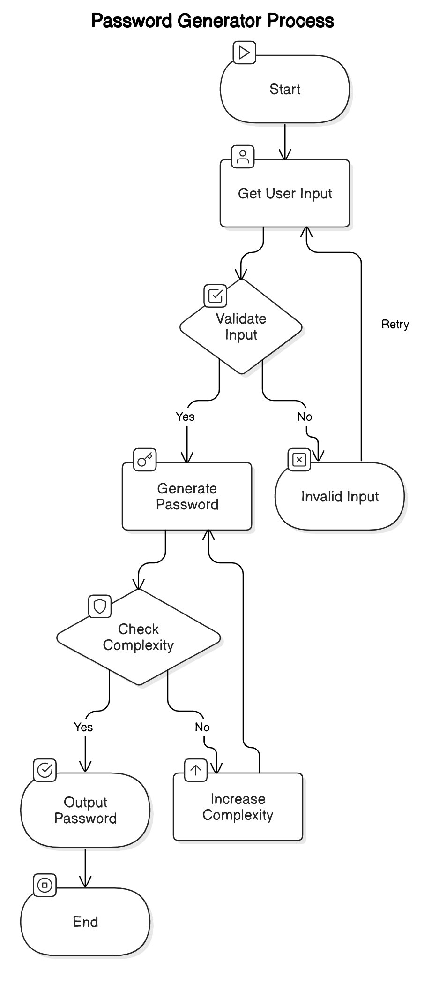

Flowchart – This depicts the details about all the functions from the top till the bottom last function.

## SUMMARY

The Password Generator project aims to create a tool that generates strong, random passwords to enhance security for both individuals and organizations. With increasing cyber threats, the need for secure password management is critical. This tool provides a solution by allowing users to generate highly secure passwords based on customizable parameters, such as length, character types (uppercase, lowercase, numbers, symbols), and the exclusion of ambiguous characters.

**Key Features:**

1. **Strong Password Generation:** Utilizes cryptographically secure randomization via Python's secrets library to ensure high entropy and resistance to common attacks.
2. **Customizability:** Users can define specific parameters like password length, inclusion/exclusion of characters, and readability options for tailored passwords.
3. **User Interface:** The project supports both a command-line interface (CLI) and a graphical user interface (GUI) built with tkinter, making the tool accessible to users with varying levels of technical expertise.
4. **Optional Storage and Export:** Provides options for securely storing passwords using encryption and exporting them for backup or integration with password management systems.
5. **Testing and Validation:** Automated unit tests validate the randomness and strength of generated passwords, ensuring compliance with security standards.

This project is designed to be a versatile and secure password generation tool, contributing to improved digital security practices for personal, enterprise, and organizational use. It prioritizes user-friendliness and flexibility, allowing both beginners and advanced users to benefit from its functionality.

THANK YOU